**VISVESVARAYA TECHNOLOGICAL UNIVERSITY, BELGAUM**

“Jnana Sangama”, Belgaum-590018

****

**A Report On**

**“NIE ACHIEVERS”**

Submitted by

**ABHINAV KUMAR 4NI18IS005**

**ARYA A.I. 4NI18IS016**

**AKSHAY KAMATH K 4NI18IS007**

Under the Guidance of

**Ms. Prathibha.B.S., Faculty2 Faculty3**

Assistant Professor

**Dept of IS&E**

**NIE, Mysuru**

****

**The National Institute of Engineering Department of Information and Engineering**

**MYSURU-570008 MYSURU-570008**

**2019-2020**

**THE NATIONAL INSTITUTE OF ENGINEERING**

**MYSURU-570008**

**Department of Information Science and Engineering**

|  |  |
| --- | --- |
|  | **D:\Documents and Settings\Chandan\Desktop\WhatsApp_files\pp_013.jpg** |

**CERTIFICATE**

Certifies that the project work titled “**NIE Achievers**” is a work carried out by **ABHINAV(4NI18IS027), ARYA A.I.(4NI18IS016), AKSHAY KAMATH(4NI18IS098)** in partial fulfilment for the requirements of the fourth semester BE in Information Science & Engineering prescribed by The National Institute of Engineering, Autonomous Institution under Visvesvaraya Technological University, Belagavi. It is certified that all corrections/suggestions indicated for Internal Assessment have been incorporated. The Project report has been approved as it satisfies the academic requirements in respect of the project work prescribed for the fourth semester in Data Base Laboratory.

Signature of Guides Signature of HOD Signature of Principal

1. (Dr. ) (Dr. )

Name of the Examiner Signature with Date

1. 1.

2. 2.

**ABSTRACT**

Our project NIE ACHIEVERS provides an easy interface for managing huge student database of different achievers of various categories like academics, sports, drama, art, dance, music and many such cultural events under one platform.

We provide this data base to the college management which provides an interface for the college management to get updates on recent events and achievements of the institution, and other details regarding the semester, name and usn of the achiever.

The access is kept exclusive to the authorized faculty or members where they can modify, update and add students, events, achievements as and when needed. It’s a password protected session.

Thus, this database will help in keeping track of the records of students and their details which can easily be accessed during the honoring ceremony which happens every year during the graduation day. Similarly, for any such requirement, this database can help one get easy access to the student achievement details faster and quicker.

**ACKNOWLEDGEMENT**

The success and the final outcome of this project required a lot of guidance and assistance from many people and we are extremely fortunate to have got this all along the completion of project work.

We express our profound thanks to **Dr. Rohini Nagapadma*,*** Principal, NIE, Mysuru for her much-needed moral support and encouragement.

We are grateful to **Dr. P. Devaki*,*** Prof.& H.O.D., Information Science and Engineering, NIE for her support and encouragement in facilitating the progress of this work.

We sincerely extend our thanks to our project Guides **Ms. Prathiba B.S., Ms. XXXXX and Ms. XXXXX** Assistant Professor in the Dept. of I.S.&E., for their guidance, technical expertise, encouragement and timely help in making this project a reality.

Also, we would like to extend our sincere regards to all the non-teaching staff of the IS&E Dept. for their timely support.

**ABHINAV KUMAR 4NI18IS005**

**ARYA A.I. 4NI18IS016**

**AKSHAY KAMATH K 4NI18IS007**

**TABLE OF CONTENTS**

**Contents Page**

1. Introduction 1

1.1 Back End 1

1.2 Database Management System 1-2

1.3 Front end 2

2. System Analysis 3

2.1 Existing Systems 3

2.2 Proposed System Explanation 3-4

2.3 Software and Hardware Requirements 4

3. System Design and Architecture 5

3.1 Design 5-7

3.2 Tables used and ER Diagram 7

4. Implementation 12

Conclusion and Future Enhancements 27

References 28

Screenshots 29

**CHAPTER 1**

**INTRODUCTION**

Management of student achievers in NIE requires to keep a track of many different activities at different timelines. This becomes a major problem as and when the number of students achieving rewards and recognition for various events both in academic and cultural field increases. Our project “NIE Achievers” provides an efficient solution to this problem. Having a unified management system for all student achievements in all fields reduces the burden on the management of the institution and paves a way to manage the achiever’s database.

Our project provides a user-friendly web interface to the management of the institution to store the data regarding the achievements of the students in a particular academic year along with their details like usn, semester, cgpa and view the achievements of the institution in various events conducted throughout the academic year and use this data when the institution need s to distribute awards to the student achievers during the graduation day where in a list of endowment awards and many such recognitions are awarded to students .

Any authorized member of the management or faculty of the institution gets the privilege to handle the student database, updating as and when the students achieve high marks or awards in sports, dance, drama, art and any such event ; whether or not to remove a student record, display the achievements of the college .

Thus, this webpage makes the access of information regarding student achievers faster, easier and also helps to get rid of the traditional and cumbersome process of manually handling data of student achievers of each category separately. Here we can access all categories regarding the student achievers of all categories in one place.

The web interface is built using HTML, CSS and Bootstrap for front end development. Databases are managed by MYSQL and the tables are linked to the webpage using PHP in the backend.

* 1. **BACK END**

A back end is nothing but a database which is used by users indirectly through an external application rather than by application programming store within the database itself. A back-end database stores data but doesn’t include end user applications.

For this project, we have used PHP to develop the back end .PHP is used to link all the tables created for this project to the webpage.

* 1. **DATABASE MANAGEMENT SYSTEM**

A database management system (DBMS) is a collection of programs that enables users to create and maintain a database. The DBMS is a general-purpose software system that facilitates the process of defining, constructing, manipulating and sharing databases among various users and applications.

A database is the process of storing the data on some storage medium that is controlled by the DBMS. Manipulating a database includes functions such as querying the database to update the database to reflect changes in the miniworld and generating reports from the data.

Some important functions provided by the DBMS include protecting the database and maintaining it over a long period of time. Protection includes system protection against software or hardware malfunction and security protection against unauthorized or malicious access. A typical large database may have a life cycle of many years, so the DBMS must be able to maintain the database system by allowing the system to evolve as requirements change over time. It is absolutely necessary to use general purpose DBMS software to implement a computerized database. We could write our own set of programs to create and maintain the database, in effect creating our own special-purpose DBMS software.

For our project, we have used MySQL which is the worlds most widely used open source relational database management system (RDBMS) that runs a server providing a multi-user access to a number of databases. The SQL phrase stands for Structured Query Language.

* 1. **FRONT END**

Front-end web development is the practice of converting data to a [graphical interface](https://en.wikipedia.org/wiki/Graphical_user_interface), so that users can view and interact with that data. Everything that you see when you’re navigating around the Internet, from fonts and colors to dropdown menus and sliders is being controlled by your computer’s browser.

For our projects front end development, we have used HTML,CSS and Bootstrap.

**CHAPTER 2**

**SYSTEM ANALYSIS**

System analysis is a detailed study of the various operations performed by a system and their relationships within and outside of the system. Here the key question is - What all problems exist in the present system? What must be done to solve the problem? Analysis begins when a user or manager begins a study of the program using existing system. During analysis, data collected on various files, decision points and transactions handled by the present system. The commonly used tools in the system are Data Flow-Diagrams, interviews, etc. training experience and common sense are required for collection of relevant information needed to develop the system. The success of the system depends largely on how clearly the problem is defined, thoroughly investigated and properly carried out through the choice of the solution. A good analysis model should provide not only the mechanism of the problem understanding but also the framework of the solution. The proposed system should be analyzed thoroughly in accordance with the needs.

**2.1 EXISTING AND SUPPORT SYSTEMS**

The existing NIE website of the institution doesn’t comprise of a facility for student achievers management and there is no such existing system with the management department of the institution. Our main aim is to bring in a new add on that can provide the institution’s management department with a user-friendly interface and also reduce the burden of manual maintenance of student achievement details of each category separately .

**2.2 PROPOSED SYSTEM**

We provide a user interface website where the achievements of the students regarding their academic performance as well as cultural achievements can be stored register and accessed by the institution whenever required. The authorized user of the management department of the institution or faculty member gets the authority to access and updates through this system about the students and their respective achievements. Faculty members can access this data whenever they have to award the students for their achievements or update or add the achievements or delete any wrong data.

This way, we are reducing the cumbersome and time-consuming method of maintaining record of the student achievers and manual calculation of highest cgpa identification. We are also solving the problem of storing separate data for each field of achievement by storing all the categories in one database which reduces time and makes access of information easier.

The institutions management member or any authorized faculty member has the access of the webpage and has the powers to add/delete students to the various teams, add/modify/delete the details about the various events for which awards were received and the positions secured in them. He can also update the student database at the end of each academic year, deleting the students who have graduated and adding them to a database of all the alumni.

Our project uses PHP 7.4.2 for the backend. MySQL is used for the database which is an RDBMS. The frontend of our website uses HTML, CSS and Bootstrap. The Materialize package of CSS and JS components is used to stylize the website. The website requires a fairly modern web browser with JS enabled.

|  |  |
| --- | --- |
| **Program or Package** | **Version used** |
| PHP | 7.4.2 |
| MySQL | 5.7 |
| HTML | 5.1 |
| CSS | 3 |
| Bootstrap | 4.4.1 |

**2.3 SOFTWARE AND HARDWARE REQUIREMENTS**

**Hardware:**

1: A dual core CPU @ 2.5GHz

2: minimum of 256 MB ram

3: 20 GB of storage

4: Fast and high bandwidth internet connection

5: A router with port forwarding setup for the server

**Software:**

1: Web browser

2: xampp

3: MySQL

4: PHP

5: CSS

6: HTML

7: Bootstrap

8: Compatible version of Linux or Windows

**CHAPTER 3**

**SYSTEM DESIGN AND ARCHITECTURE**

**3.1 DESIGN**

The website is made using Flask on Python 3.6. MYSQL is used as the database manager. The frontend is made using HTML, CSS and JS. The details of these libraries, modules and languages are given below:

**3.1.1 HTML**

HTML or HYPERTEXT MARKUP LANGUAGE is a standard markup language used to create webpages. The main function of a web browser is to read HTML documents and compose them into visible or audible web pages. HTML elements are the building blocks of HTML pages. With HTML constructs, images and other objects such as interactive forms, may be embedded into the rendered page. HTML provides a means to create structured documents by denoting structural semantics for text such as headings, paragraphs, lists, links, quotes and other items. HTML elements are delineated by tags, written using angle brackets. Tags such as <img/> and <input/> directly introduce content into the page. Other tags such as <p> surround and provide information about document text and may include other tags as sub-elements. The browser does not display the HTML tags that are used to create the webpages, but uses the tags to interpret and represent the content of the page. HTML describes the structure of a website semantically along with cues for presentation, mailing it a markup language rather than a programming language.

**3.1.2 Cascading style sheets**

Cascading style sheets (CSS) is a style sheet language used for describing the presentation of a document written in a markup language. Although most often used to set the visual style of web pages and user interface written in HTML and Hotplate language can be applied to any XML document, including plain XML, SVG and XUL, and is applicable to reading in speech or on other media. Web browsers can refer to CSS to define the look and layout of text and other material. The W3C maintainer of both the HTML and the CSS standards, encourages the use of CSS over explicit presentational HTML. Along with HTML and JavaScript, CSS is a technology used by most websites to create visually engaging web pages, user interface for web applications, and user interface for many mobile applications. CSS is designed primarily to the separation of document content from document presentation, including aspects such as the layout, colors and fonts. This separation can improve content accessibility, provide more flexibility and control in the specification of presentation characteristics, enable multiple HTML pages to share formatting by specifying the relevant CSS in a separate .CSS file, and reduce complexity and repetition in the structural content.

**3.1.3 Bootstrap**

Bootstrap is a [free and open-source](https://en.wikipedia.org/wiki/Free_and_open-source) [CSS framework](https://en.wikipedia.org/wiki/CSS_framework) directed at responsive, [mobile-first](https://en.wikipedia.org/wiki/Responsive_web_design#Mobile_first,_unobtrusive_JavaScript,_and_progressive_enhancement) [front-end web development](https://en.wikipedia.org/wiki/Front-end_web_development). It contains [CSS](https://en.wikipedia.org/wiki/CSS)- and (optionally) [JavaScript](https://en.wikipedia.org/wiki/JavaScript)-based design templates for [typography](https://en.wikipedia.org/wiki/Web_design#Typography), [forms](https://en.wikipedia.org/wiki/Form_(HTML)), [buttons](https://en.wikipedia.org/wiki/Button_(computing)#HTML), [navigation](https://en.wikipedia.org/wiki/Web_navigation#Local_website_navigation), and other interface components.

Bootstrap is a web framework that focuses on simplifying the development of informative web pages (as opposed to [web apps](https://en.wikipedia.org/wiki/Web_Apps)). The primary purpose of adding it to a web project is to apply Bootstrap's choices of colour, size, font and layout to that project. As such, the primary factor is whether the developers in charge find those choices to their liking. Once added to a project, Bootstrap provides basic style definitions for all [HTML elements](https://en.wikipedia.org/wiki/HTML_element). The result is a uniform appearance for prose, tables and form elements across [web browsers](https://en.wikipedia.org/wiki/Web_browser). In addition, developers can take advantage of CSS classes defined in Bootstrap to further customize the appearance of their contents. For example, Bootstrap has provisioned for light- and dark-coloured tables, page headings, more prominent pull quotes, and text with a highlight.

Bootstrap also comes with several JavaScript components in the form of [jQuery](https://en.wikipedia.org/wiki/JQuery) plugins. They provide additional user interface elements such as [dialog boxes](https://en.wikipedia.org/wiki/Dialog_box), [tooltips](https://en.wikipedia.org/wiki/Tooltip), and carousels. Each Bootstrap component consists of an HTML structure, CSS declarations, and in some cases accompanying JavaScript code. They also extend the functionality of some existing interface elements, including for example an auto-complete function for input fields.

**3.1.4 MySQL**

MySQL is an open source relational database management system (RDBMS). MySQL enables data to be stored and accessed across multiple storage engines, including InnoDB, CSV, and NDB. MySQL is also capable of replicating data and partitioning tables for better performance and durability. MySQL users aren't required to learn new commands; they can access their data using standard SQL commands.

For security, MySQL uses an access privilege and encrypted password system that enables host-based verification. MySQL clients can connect to MySQL Server using several protocols, including TCP/IP sockets on any platform. MySQL also supports a number of client and utility programs, command-line programs and administration tools such as MySQL Workbench. Different programming languages have modules and libraries that enable the use of MySQL.

**3.1.5 PHP**

PHP is a popular general-purpose scripting language that is especially suited to web development. It was originally created by [Rasmus Lerdorf](https://en.wikipedia.org/wiki/Rasmus_Lerdorf) in 1994; the PHP [reference implementation](https://en.wikipedia.org/wiki/Reference_implementation) is now produced by The PHP Group. PHP originally stood for Personal Home Page, but it now stands for the [recursive initialism](https://en.wikipedia.org/wiki/Recursive_initialism) PHP: Hypertext Pre-processor.

PHP code is usually processed on a web server by a PHP [interpreter](https://en.wikipedia.org/wiki/Interpreter_(computing)) implemented as a [module](https://en.wikipedia.org/wiki/Plugin_(computing)), a [daemon](https://en.wikipedia.org/wiki/Daemon_(computing)) or as a [Common Gateway Interface](https://en.wikipedia.org/wiki/Common_Gateway_Interface) (CGI) executable. On a web server, the result of the interpreted and executed PHP code – which may be any type of data, such as generated HTML or binary image data – would form the whole or part of a HTTP response. Various [web template systems](https://en.wikipedia.org/wiki/Web_template_system), web [content management systems](https://en.wikipedia.org/wiki/Content_management_system), and [web frameworks](https://en.wikipedia.org/wiki/Web_framework) exist which can be employed to orchestrate or facilitate the generation of that response. Additionally, PHP can be used for many programming tasks outside of the web context, such as [standalone](https://en.wikipedia.org/wiki/Computer_software) [graphical applications](https://en.wikipedia.org/wiki/Graphical_user_interface) and robotic [drone](https://en.wikipedia.org/wiki/Unmanned_aerial_vehicle) control. Arbitrary PHP code can also be interpreted and executed via [command line interface](https://en.wikipedia.org/wiki/Command-line_interface) (CLI).

PHP is the most popular as well as the most used scripting language for web application development. Developers count on PHP language when it comes to backend development of their Web Apps project. PHP (Hypertext Preprocessor), is a server-side scripting language designed for Web development, but also used as a general-purpose programming language. In our project, we have used PHP to link all the tables to the webpage.

**3.2 TABLES USED AND ER-DIAGRAM**

**3.2.1 Student Table**

|  |  |  |  |  |  |
| --- | --- | --- | --- | --- | --- |
| Field | Type | Null | Key | Default | Extra |
| USN | varchar (10) | No | PRI | NULL |  |
| Name | varchar (20) | Yes |  | NULL |  |
| Branch | varchar (10) | Yes |  | NULL |  |
| Sem | int (1) | Yes |  | NULL |  |

The student table is used to store the details of the student achievers. It stores information regarding the USN of the student which is unique to each student and thus is made the primary key. This table also stores the names, branches and semester of the student achiever.

**3.2.2 Department table**

|  |  |  |  |  |  |
| --- | --- | --- | --- | --- | --- |
| Field | Type | Null | Key | Default | Extra |
| Dno | int (5) | No | PRI | NULL |  |
| Dname | varchar (20) | Yes |  | NULL |  |

The department table contains the details regarding the different department numbers and department names that are present within the institution. Here the department number is the primary key because each department will have its own unique department number.

**3.2.3 Academics table**

|  |  |  |  |  |  |
| --- | --- | --- | --- | --- | --- |
| Field | Type | Null | Key | Default | Extra |
| Dno | Int (5) | Yes | MUL | NULL |  |
| Sem | Int (1) | Yes | - | NULL |  |
| USN | Varchar (10) | No | PRI | NULL |  |
| CGPA | Float | Yes | - | NULL |  |
| Rank | Int (11) | No | - | NULL |  |

The academics table contains details like Dno which will act us the foreign key which references the department table to get the other information regarding academics. This table also contains the details of semester, cgpa and rank secured by the students. It also stores usn which is the primary key.

**3.2.4 Sports table**

|  |  |  |  |  |  |
| --- | --- | --- | --- | --- | --- |
| Field | Type | Null | Key | Default | Extra |
| sports\_name | varchar (30) | No | PRI | NULL |  |
| Winners | varchar (10) | Yes | MUL | NULL |  |
| Runnerups | varchar (10) | Yes | MUL | NULL |  |

The sports table stores details regarding the name of the sport that the student has achieved an award in which is unique to every student and thus is made the primary key. It stores the winners and runner up details also which acts as foreign keys and references the academics and department table to get the further sports details.

**3.2.5 Event table**

|  |  |  |  |  |  |
| --- | --- | --- | --- | --- | --- |
| Field | Type | Null | Key | Default | Extra |
| event\_id | varchar (5) | No | PRI | NULL |  |
| event\_name | varchar (50) | Yes |  | NULL |  |

The event table stores details regarding the different events students have received awards in. It stores the event id which acts as the primary key as it is unique for each event and also stores the name of the event.

**3.2.6 Cultural\_talent table**

|  |  |  |  |  |  |
| --- | --- | --- | --- | --- | --- |
| Field | Type | Null | Key | Default | Extra |
| event\_id | varchar (10) | No | PRI | NULL |  |
| Winner | varchar (10) | Yes | MUL | NULL |  |
| Runnerups | varchar (10) | Yes | MUL | NULL |  |

The cultural talent table stores details of the event id which is a primary key as it will be unique. It also stores the winners and runner up details which references the student table to get further information regarding the student details.

**ER DIAGRAM**

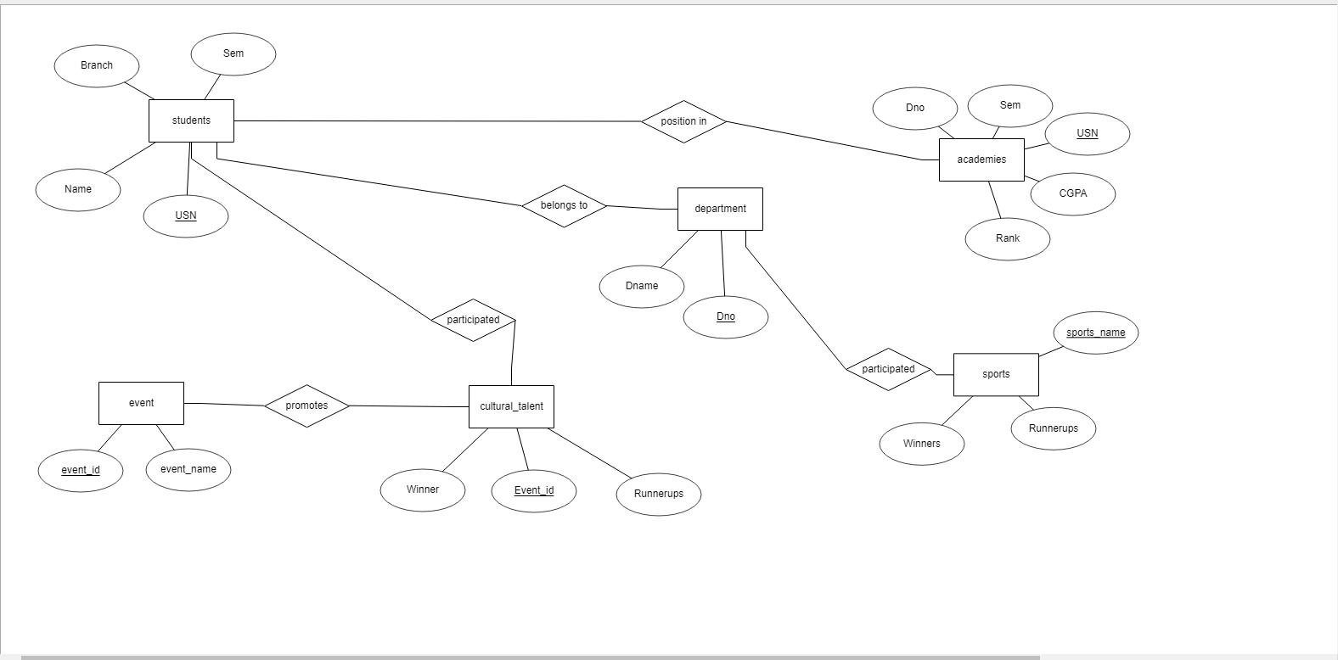

Fig 3.1- The ER diagram comprises of all the relationships between the tables and the attributes

The above figure (Fig 3.1) is a representation of the Entity-Relationships model of the database system which is being designed. The tables, which are represented by the rectangular blocks are the entities involved in the database system, each of which may or may not be connected to the other entities through relations.

**SCHEMA DIAGRAM**

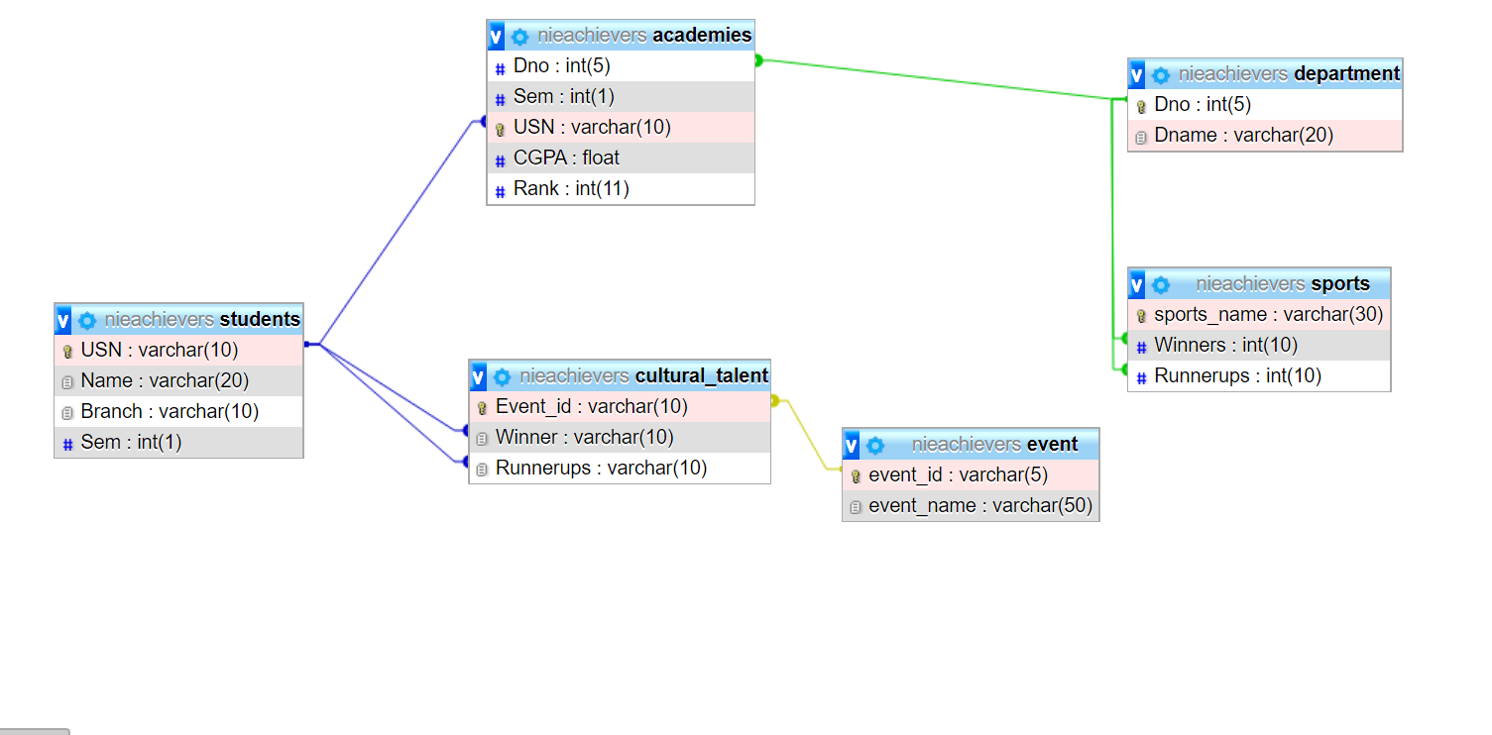

**CHAPTER 4**

**IMPLEMENTATION**

* To create table academies:

CREATE TABLE academies (Dno int (5), Sem int (1), USN varchar (10) PRIMARY KEY, CGPA float, Rank int (11), FOREIGN KEY(Dno) references department (Dno));

* To display academies table:

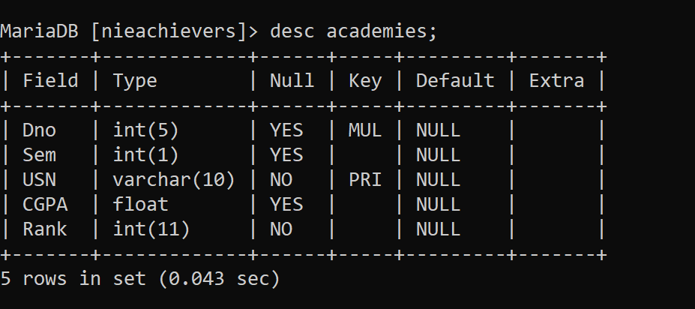

* To display values of academies

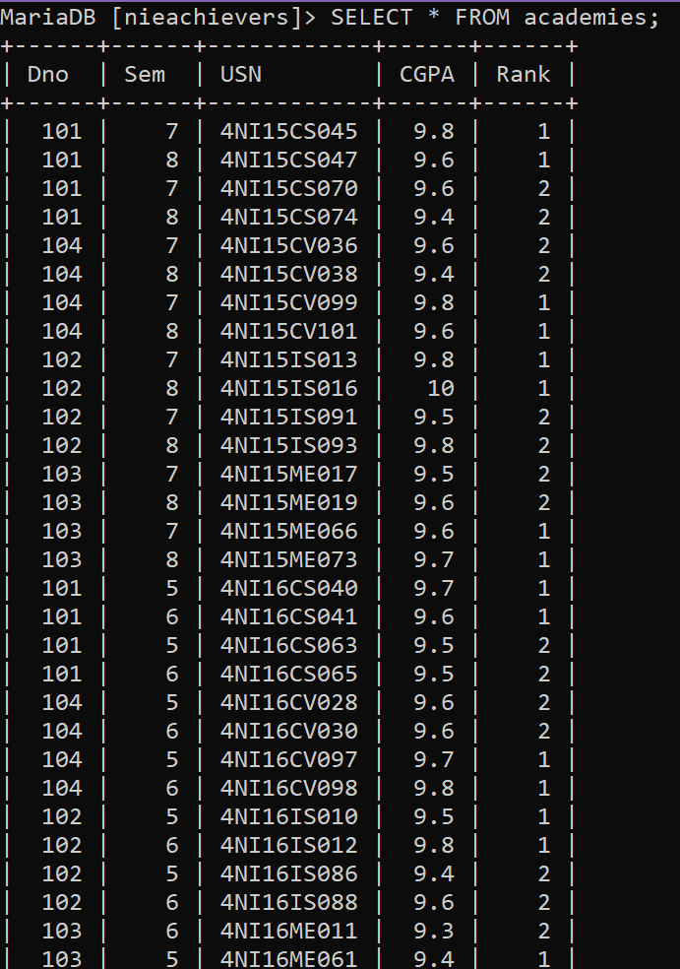

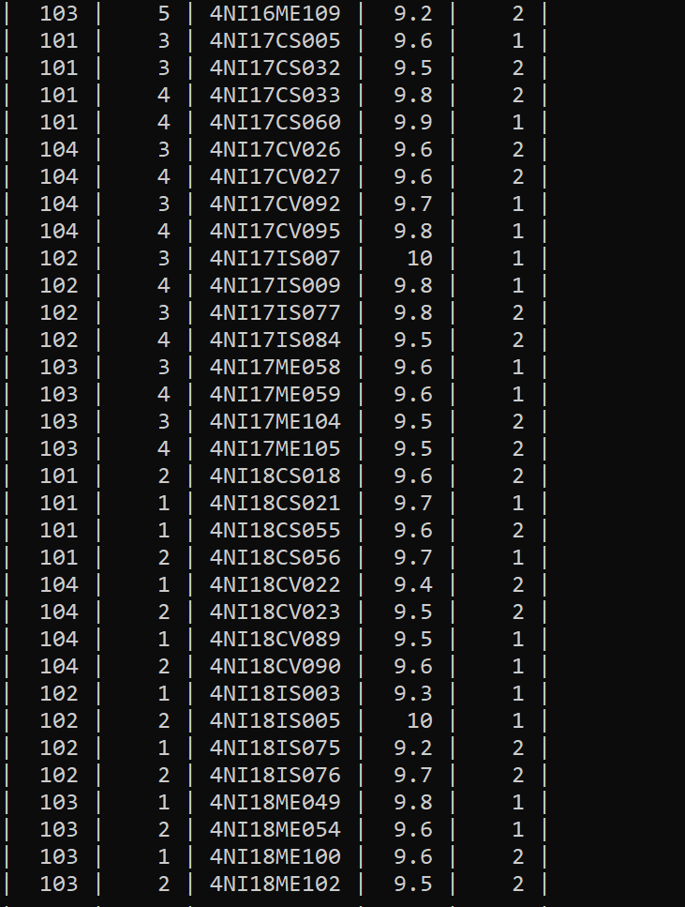

* To create table students:

CREATE TABLE students (USN varchar (10) PRIMARY KEY, Name varchar (20), Branch varchar (10), Sem int (1));

* To display table students:

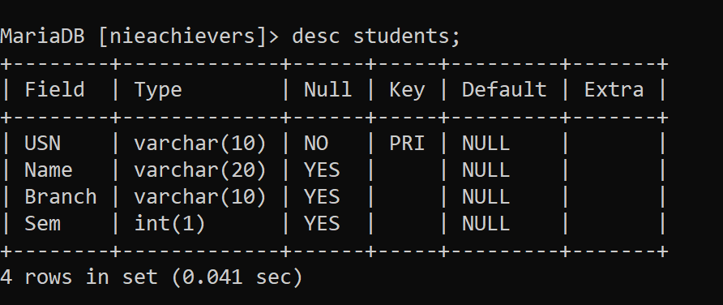

* To display values of students

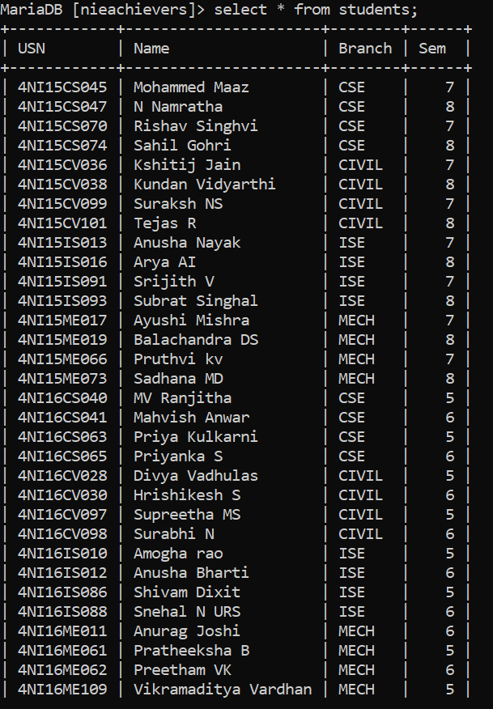

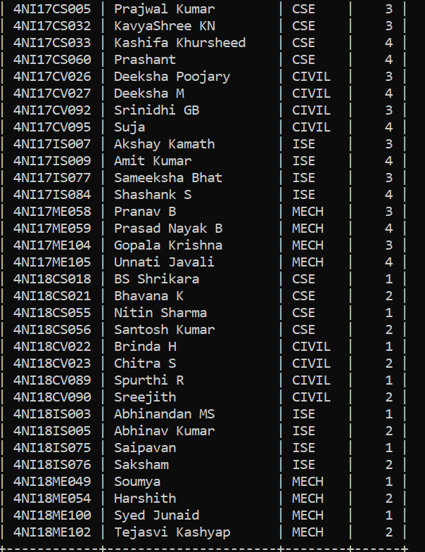

* To create table department:

CREATE TABLE department (Dno int(5) PRIMARY KEY ,Dname varchar(20));

* To display table department

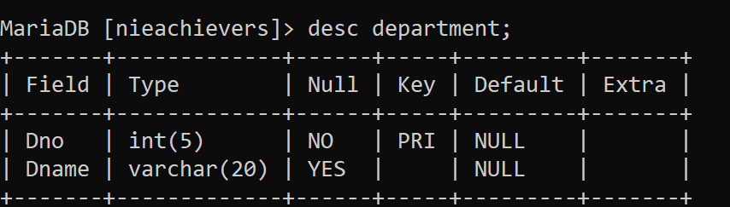

* To display values of department

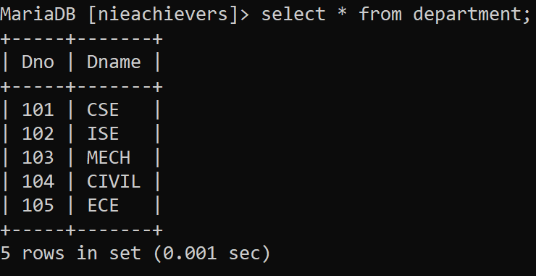

* To create table sports:

CREATE TABLE sports (sports\_name varchar(30) PRIMARY KEY, Winners int(10), Runnerups int(10),FOREIGN KEY(Winners) references department(Dno), FOREIGN KEY(Runnerups) references department(Dno));

* To display sports table:

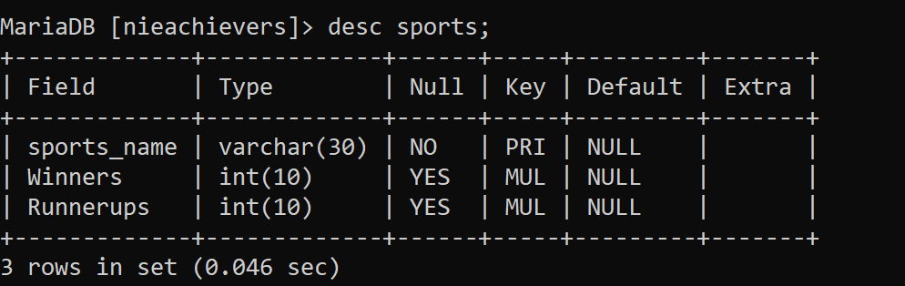

* To display values of sports

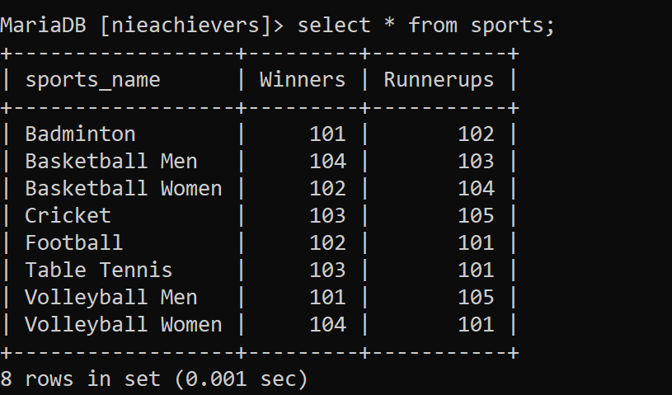

* To create table cultural\_talent:

CREATE TABLE cultural\_talent (Event\_id varchar (10) PRIMARY KEY, Winner varchar (10), Runnerups varchar(10) ,FOREIGN KEY (Event\_id) references event (event\_id),FOREIGN KEY (Winner) references students(USN),FOREIGN KEY (Runnerups) references students(USN));

* To display table cultural\_talent:

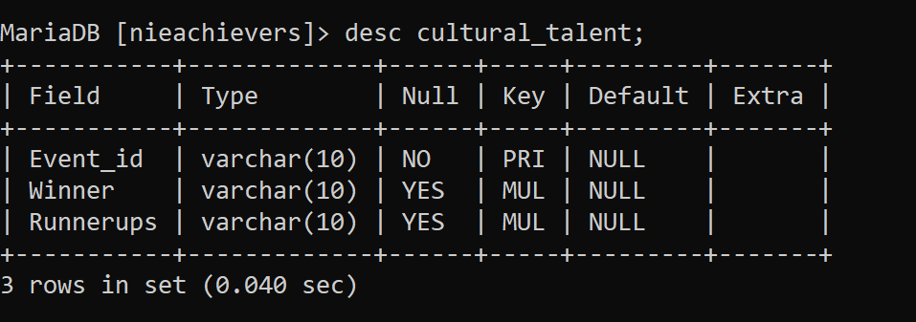

* To display values of cultural\_talent

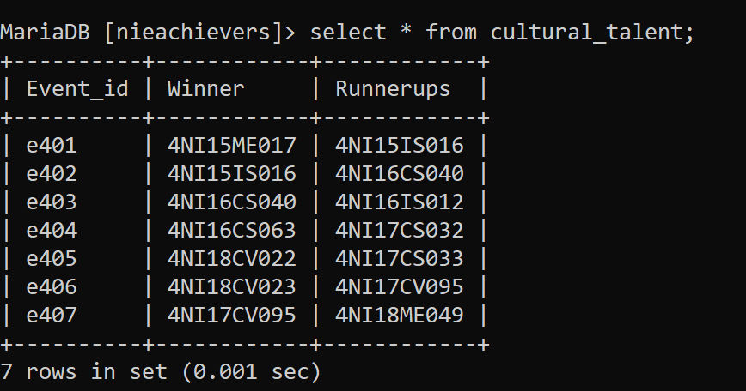

* To create table event:

CREATE TABLE event (event\_id varchar (5) PRIMARY KEY, event\_name varchar (50));

* To display event table:

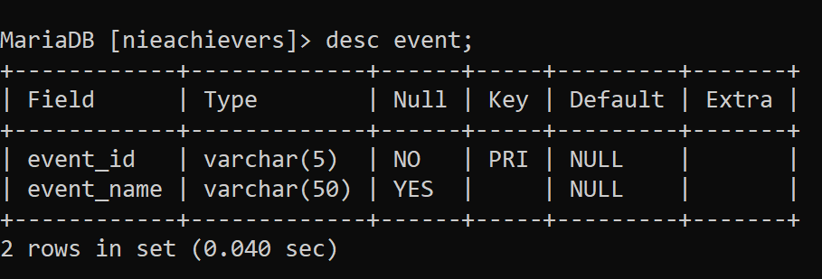

* To display value of event

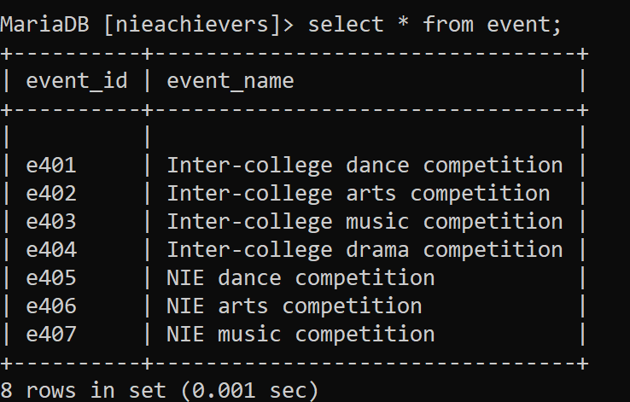

**CONCLUSION AND FUTURE ENHANCEMENTS**

The purpose of the webpage was to create a platform for the management of the institution where student achiever’s information who have received awards and recognition in various fields like academics, sports, art, dance, music and many more are recorded in the database. This helps the faculty members get the information immediately and quickly whenever they need it. With this webpage, we give the management department of the institution a platform to maintain a student database, and keep a track of all the events and the achievements of the students at one platform instead of maintaining separate data for all events.

We have strived to achieve most of the goals that we had planned at the beginning of this project.

Future enhancements may include further functionality such as email notifications for the students at the end of the academic year inviting them to the award ceremony during the graduation day or any such award distribution event. Also, the facility to add on more events like technical papers presented by students in recognizable platforms, achievements of the clubs of the institution and such appreciable events.

**REFERENCES**

1) Narain Gehani, The Database book: Principles and Practice using MySQL (India) private limited, 2008

2) https://www.w3schools.com/ for HTML, CSS and Bootstrap

**SCREENSHOTS**

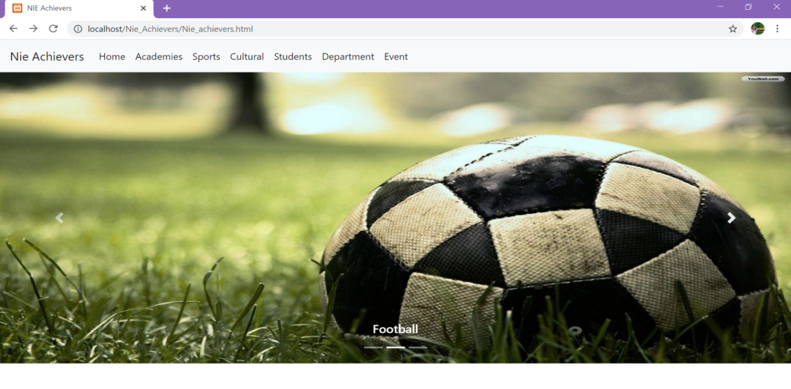

**This is the web interface of our database project.**

**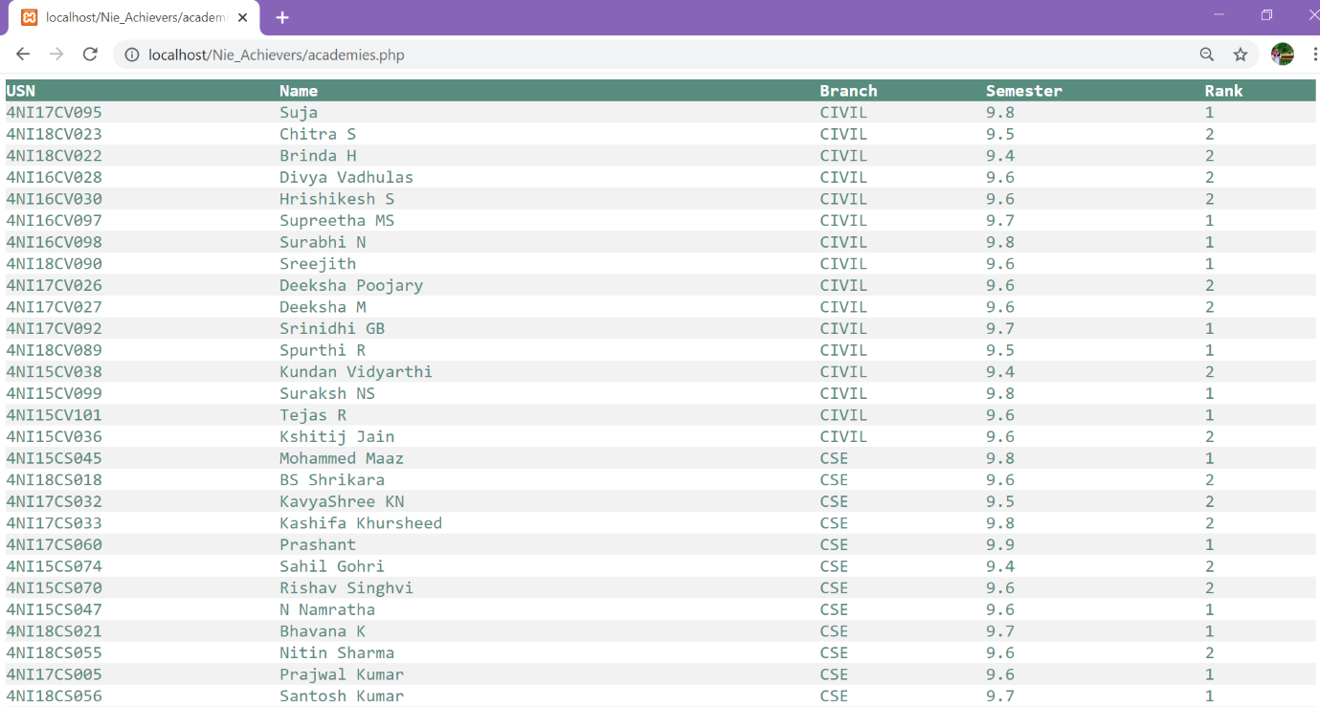**

**This is the academies details of the students.**

**Query is** "SELECT s.USN, s.Name, s.Branch, a.CGPA, a.Rank FROM students s,academies a where s.USN = a.USN order by Branch";

**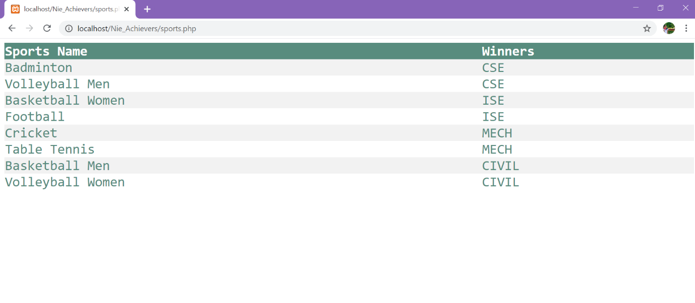**

**This table has the list of winning departments in various sports.**

**Query is** "Select sp.sports\_name,d.Dname from sports sp, department d where d.Dno = sp.Winners;"

**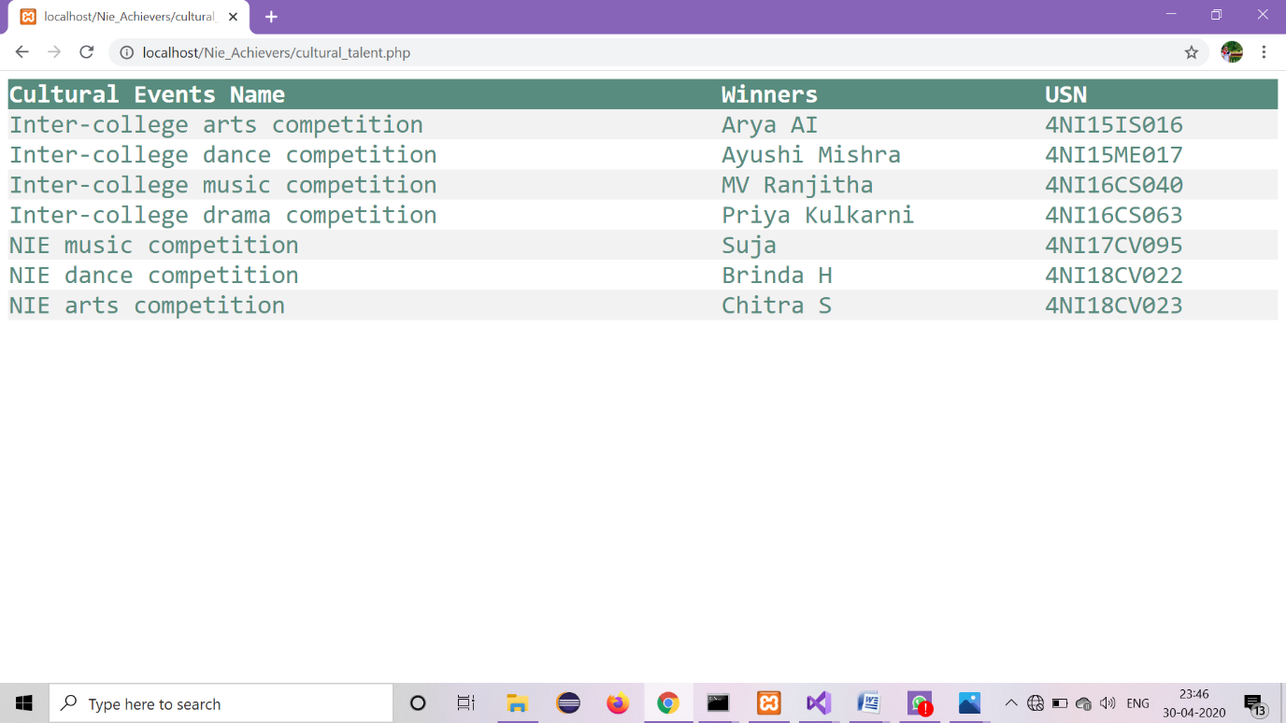**

**This table has the list of participants who won different cultural Events.**

**Query is** "Select e.event\_name, s.name, s.USN from students s,event e,cultural\_talent c where e.event\_id = c.event\_id and s.usn = c.winner ;"